Midterm Examination
Fundamental Electronics Circuit Laboratory

Name: Date:
Course/Subject:
Instruction:
- Discuss the following problem below with your own understanding and learning from this course. This will examine your learning during the laboratory activities you have done.
- This exam is an individual activity; avoid copying from your classmates. If I find the same answer as your classmates, both of you will be marked as zero.
- Please explain it yourself. An AI-generated answer will be equivalent to zero points. I have applications that can check whether your answer is from an AI. No handwritten required on your answer, just add here in this document.

Examination Questions:
- Provide the required information that is asked for the circuit in Figure 1. Circuit calculations can be manually calculated, and a picture can be taken and then inserted into this document.
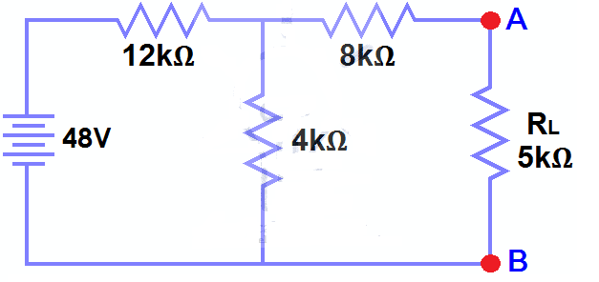
Figure 1
- Calculate the circuit in Figure 1 to find the IL and VL in the RL using any type of Network Theorem.
Rp = (12kΩ x 4kΩ) / (12kΩ + 4kΩ ) = 11kΩ
Rth = 3kΩ + 8kΩ = 11kΩ

Vth = 48V x ((4kΩ) / (12kΩ + 4kΩ) = 48V x (4/16) = 12V
IL = 12V / (11kΩ + 5kΩ) = 0.75 mA
VL = 0.75 mA x 5kΩ = 3.75v

- Calculate the circuit in Figure 1 to find all currents and voltages in all resistors using Ohm's Law and Kirchhoff's Law.
Rt = 12kΩ + 3.059kΩ = 15.059kΩ
RL = 3.75V
R(8kΩ) = 6V
R(4kΩ) = 9.756V
R(12kΩ) = 38.244V

- Simulate the circuit in Figure 1using NI Multisim.
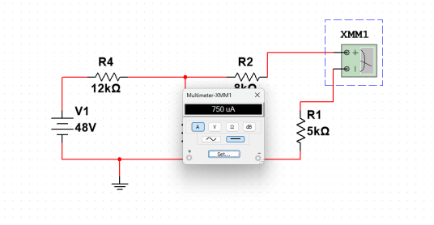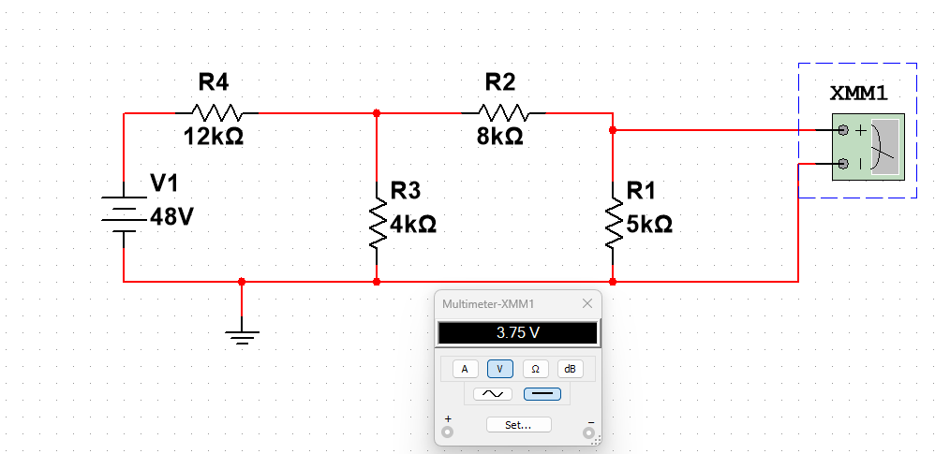
- Discuss all the learning that you have gained (from calculating the circuit to actual measurement) from this activity based on the circuit in Figure 1. (minimum 200 words)
First I solve the a in theoretical so I can have a support when im doing the figure 1 in multism, so the important ones that I prioritize to find is the IL and the VL, after you get that you will also get the Rth. After getting IL, VL, and Rth it was now easy to solve the other resistors voltage and currents. After that I now tried to do the figure in Multism. After copying the figure i put an ground node at the bottom because this is an important part. Now I set all the values needed for each resistors and DC, as you can see in the figure there is atleast 4 resistors and a DC, I set each resistor from right to left, 5kΩ, 8kΩ, 4kΩ, and 12kΩ. Then I set the DC into 48 volts. After that I take a multimeter and first get the VL, the multimeter should be places parallel if you are getting volts so I put the negative in the bottom then the positive on the top. And that is how I got the value of 3.75V for the VL. Next is I tried to get the IL, for that the multimeter should be in series so I remove the connection of r1 and r2 then connect the multimeter at the middle so it will act as a series. Now that is how I got the value of 750 ua or 0.75mA. The two values that I got correlate to the theoretical that I did.

- Carefully read the section below and provide complete and accurate responses to each question presented.
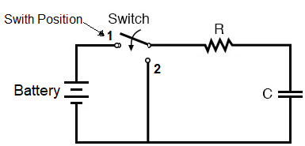
Figure 2.
- Explain your circuit analysis from the circuit in Figure 2. (minimum 200 words)
The first highlight of this circuit is that it has a switch. Typically switch are use to change the path of the current and it can be seen here in figure 2. There is 2 path, first patch connects to a DC source or battery, it then loops into a capacitor and the resistor, the second path removes the battery or the DC source from the loop. So what is the point of the switch?.
Lets first look what will happen if the switch is at the first path, because it has a capacitator and the DC source, the capacitator then will act like a short circuit, which then allow the maximum current to flow. As time progress, the capacitor will gain charges and voltage that goes across it will then increase exponentially.
Now lets look on what happen if the switch is turned into the second path. It will first remove the battery from the loop and the loop will just be a the capacitor and the resistors. In this state, all the stored energy of the capacitator will dissipate because of the resistors, The voltage will decrease exponentially from maximum value into 0.

- Provide a signal response diagram of voltage and current if the switch is at position 1 and position 2. Note: Draw your own graph and explain it. (Minimum 200 words)

The diagram I draw show the basic graph of how the voltage and current of each path will rise or decrease.

Current:
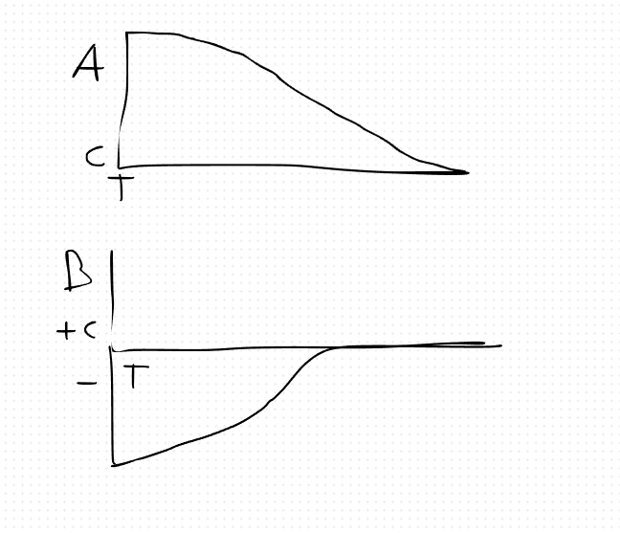
Voltage:
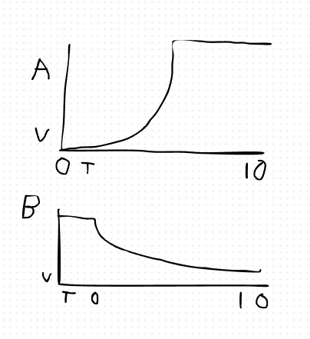

- Carefully read the section below and provide complete and accurate responses to each question presented.

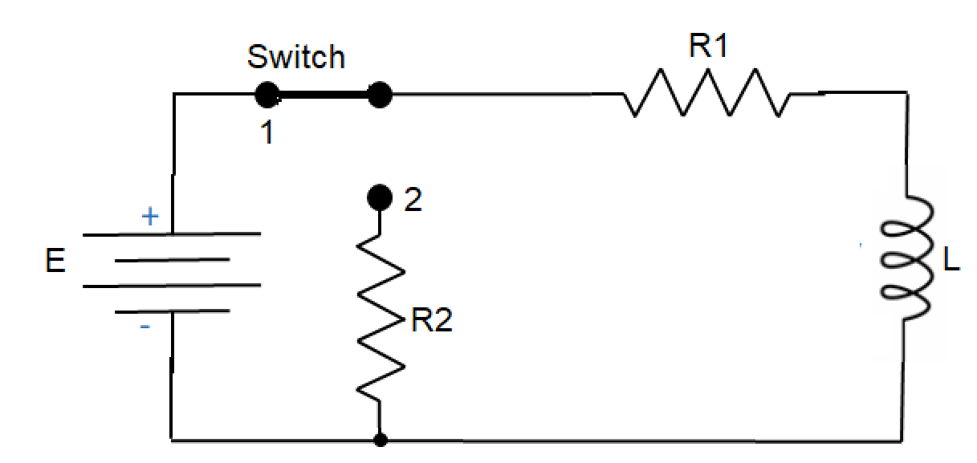
Figure 3.
- Explain your circuit analysis from the circuit in Figure 3. (minimum 200 words)
The circuit in Figure 3 is a RL network. It has a DC voltage source, a switch, two resistors and an inductor. The inductor is important here. Inductors do not like it when the current changes. They try to stop the change. On the hand capacitors do not like it when the voltage changes.

When we move the switch to Position 1 the battery, one resistor and the inductor make a loop. At first the inductor does not let any flow. It is like a circuit. This is because the inductor is resisting the change from no current to some current. As time passes a magnetic field builds up around the inductor. The current gets stronger and stronger. It grows fast at first and then it slows down. The time it takes to get to the current is decided by the inductor and one resistor.

After some time the inductor is like a wire. It lets the current flow. The current is decided by the battery and one resistor.

Moving the switch to Position 2 changes everything. The battery is disconnected. The inductor is now in a loop, with the two resistors. The
inductor uses the energy it stored to keep the flowing. This is when the inductor is discharging. The current gets weaker and weaker. It is like the inductor is losing its energy. The energy is lost as heat in the resistors. The current keeps getting weaker until it's zero.

- Provide a signal response diagram of voltage and current if the switch is at position 1 and position 2. Note: Draw your own graph and explain it. (Minimum 200 words)
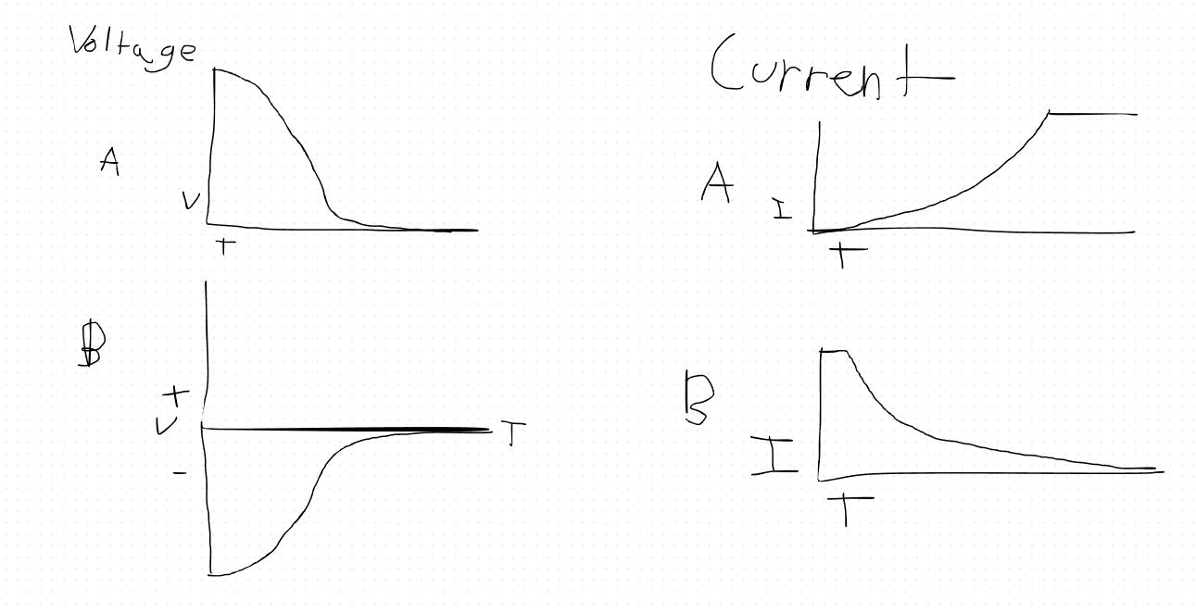
The signal response of the RL circuit in Figure 3 shows us how an inductor really works. An inductor does not like it when the flow of current changes suddenly. When we move the switch to Position 1 the inductor does not want the electricity from the DC source to come in. At first the inductor acts like a break in the wire. No current flows. This happens even though the battery is pushing against it with its voltage.

As time passes a magnetic field starts to form around the inductor. The inductor then starts to allow the current to flow. It does so in a smooth and steady way. The magnetic field gets stronger and stronger until it is fully established and stable. At this point the inductor does not stop the flow of current anymore. It acts like a regular wire. The voltage across the inductor is zero so the maximum amount of current can flow through the resistors.

When we move the switch to Position 2 the battery is no longer connected,. The inductor helps keep the current flowing. The inductor uses the energy it stored to keep the electricity moving in the same direction. To keep this energy flowing through the resistors the voltage from the inductor changes direction and creates a negative spike. The current then slowly disappears as the stored energy is used up. The RL circuit in Figure 3 and the inductor, in it show us how this works. The inductor and the RL circuit are important to understand.

- Using laboratory activity in Series R, L, C Circuits provides the following requirements and simulates using NI Multisim.
Equipment
  - AC Function Generator
  - Oscilloscope
Components
  - 10 nF
  - 10 mH
  - 1 kΩ

Schematics
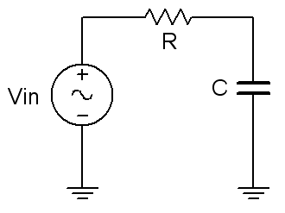
Figure 6.1

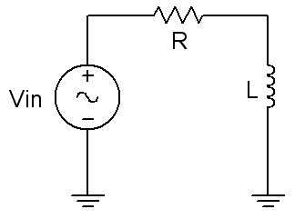
Figure 6.2

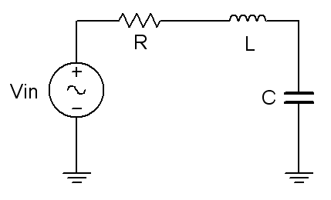
Figure 6.3
Procedure

RC Circuit

- Using Figure 6.1 with Vin=2 V p-p sine at 10 kHz, R=1 kΩ, and C=10 nF, determine the theoretical capacitive reactance and circuit impedance, and record the results in Table 6.1 (the experimental portion of this table will be filled out in step 5). Using the voltage divider rule, compute the resistor and capacitor voltages and record them in Table 6.2.
- Build the circuit of Figure 6.1 using R=1 kΩ, and C=10 nF. Place one probe across the generator and another across the capacitor. Set the generator to a 10 kHz sine wave and 2 V p-p. Make sure that the Bandwidth Limit of the oscilloscope is engaged for both channels. This will reduce the signal noise and make for more accurate readings.
- Measure the peak-to-peak voltage across the capacitor and record in Table 6.2. Along with the magnitude, be sure to record the time deviation between VC and the input signal (from which the phase may be determined). Using the Math function, measure and record the voltage and time delay for the resistor (Vin – VC). Compute the phase angle and record these values in Table 6.2.
- Take a snapshot of the oscilloscope displaying Vin, VC, and VR.
- Compute the deviations between the theoretical and experimental values of Table 6.2 and record the results in the final columns of Table 6.2. Based on the experimental values, determine the experimental Z and XC values via Ohm’s Law (i=VR/R, XC=VC/i, Z=Vin/i) and record back in Table 6.1 along with the deviations.
- Create a phasor plot showing Vin, VC, and VR. Include both the time domain display from step 4 and the phasor plot with the technical report.

RL Circuit
- Replace the capacitor with the 10 mH inductor (i.e. Figure 6.2), and repeat steps 1 through 6 in like manner, using Tables 6.3 and 6.4.

RLC Circuit
- Using Figure 6.3 with both the 10 nF capacitor and 10 mH inductor, repeat steps a through f in like manner, using Tables 6.5 and 6.6. Unfortunately, it will be impossible to see the voltage of all three components simultaneously with the source voltage using a two-channel oscilloscope. To obtain proper readings, place the first probe at the input and the second probe across the capacitor in order to see the phase and magnitude of VC. Then, swap C and L (placing the second probe across the inductor) to see VL, and finally, swap L and R (with the second probe across R) in order see VR.

Data Tables
RC Circuit
 | Theory | Experimental | % Deviation

X_{C}

Z Magnitude

Z θ

Table 6.1

 | Theory Mag | Theory θ | Exp Mag | Exp Delay | Exp θ | % Dev Mag | % Dev θ
V_{C}
V_{R}

Table 6.2

 | Theory | Experimental | % Deviation

X_{L}

Z Magnitude

Z θ
RL Circuit

Table 6.3

 | Theory Mag | Theory θ | Exp Mag | Exp Delay | Exp θ | % Dev Mag | % Dev θ
V_{L}
V_{R}

Table 6.4
RLC Circuit
 | Theory | Experimental | % Deviation

X_{C}

X_{L}

Z Magnitude

Z θ

Table 6.5

 | Theory Mag | Theory θ | Exp Mag | Exp Delay | Exp θ | % Dev Mag | % Dev θ
V_{C}
V_{L}
V_{R}

Table 6.6

Questions
- What is the phase relationship between R, L, and C components in a series AC circuit?
- Based on measurements, does Kirchhoff’s Voltage Law apply to the three tested circuits (show work)?
- In general, how would the phasor diagram of Figure 6.1 change if the frequency was raised?
- In general, how would the phasor diagram of Figure 6.2 change if the frequency was lowered?

Good luck and God bless!!!

